CANDIDATE PROFILE

Position: Front desk
Accepts different/lower position offers : Yes Candidate
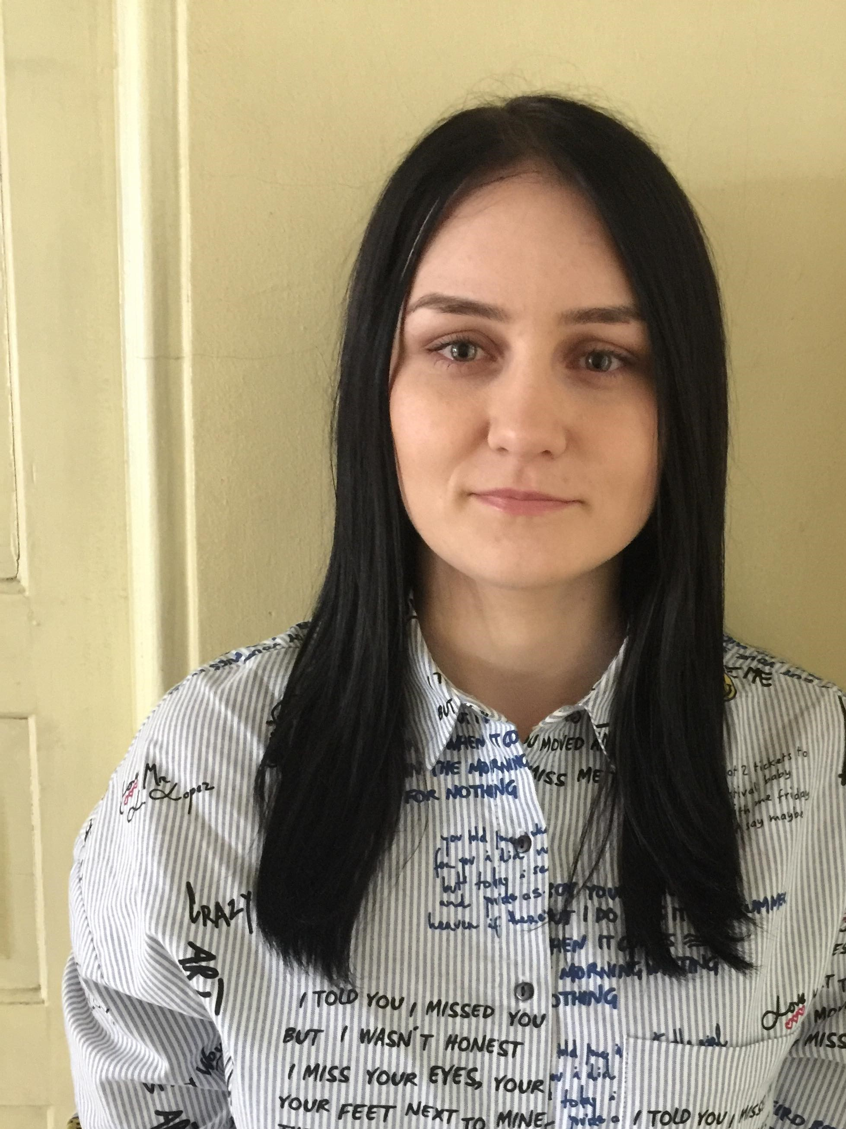
Name / Surname : Alina Gabriela Prisacariu
Date of birth: 23.03.1994
Address: Str. Principala 66C, Valea Adanca, Iasi, Romania
Telephone: +40 757 255 586
E-mail: alina.prisacariu94@gmail.com
Nationality: Romanian
Skype(social): alina.prisacariu94

Education

Period | 2013 - Onwards
Educational Institution | Gh. Asachi Technical University, Iasi, Romania
Degree | Bachelor’s in Electronical Engineering in Microelectronics, Optoelectronics and Nanotechnology

Professional Experience

Period | March 2015 – April 2018
Employer | Concord Service Center SRL, Iasi
Position | Internship / Technician in Computing Equipment and Networking – COR 351103
Special Duties & Responsibilities | - Troubleshooting/testing/repairing/teardown smartphones/headphones (Beats by Dre)  - Coordinate and execute various testing activities to verify and detect defects within.  - Collect and deliver required testing information for client(s) in a timely manner.  - Execute test cases (manual or automated) and analyze results.  - Collaborate with team members to develop effective strategies and test plans.  - Scanning, packing handling, and wiping smartphones.  - Maintain inventory control of equipment tools and parts.

Period | April 2018 - Onwards
Employer | Atexis SRL Iasi
Position | Technical Author – Aircraft Maintenance Manual (AMM), Airbus Civil Aircraft
Special Duties & Responsibilities | - Prepare and develop the technical documentation data in accordance with the international standard  ASD1000D.  - Prepare text and illustrations mock-ups.  - Give answers for Airbus Request for Information (RFI) requests and then incorporate the changes, if  necessary.  - Make the evaluation and incorporation for the Customer Originated Changes (COC).  - Write and develop technical publications manuals.  - Collect and check the source data for adequacy and completeness and use it in accordance.  - Read technical drawings, schematics and production layouts.  - Perform the internal and external quality process, Verification and Validation (V&V) steps and apply  the relevant modifications in case needed.

Language Skills / level (beginner, medium, advanced)
- Romanian: Native
- English: Advanced
- German: No experience
- Other languages: Spanish (Advanced)

References and Diplomas:

Availability: As per offer

Salary Expectations: As per offer

Consent to Use Job Application Data (GDPR)

As part of any recruitment process, Auras Recruitment collects and processes personal data relating to job applicants. The company is committed to being transparent about how it collects and uses that data and to meeting its data protection obligations as per GDPR regulation. This Statement aims at informing you of how Auras Recruitment is going to use the information you submit when applying for a job.

Data will be stored in a range of different secured places, including on your application record, in HR management systems and on other IT systems (including email).

We need to process data to take steps at your request prior the employers to entering into a contract with you. We may also need to process your data for the employers to enter into a contract with you. In some cases, we need to process data to ensure that we are complying with its legal obligations.

Auras Recruitment has a legitimate interest in processing personal data during the recruitment process and for keeping records of the process. Processing data from job applicants allows us to manage the recruitment process, assess and confirm a candidate's suitability for employment and decide to whom to offer a job.

If your application is unsuccessful, Auras Recruitment may keep your personal data on file in case there are future employment opportunities for which you may be suited. We will ask for your consent before we keep your data for this purpose and you are free to withdraw your consent at any time. If your application for employment is successful, personal data gathered during the recruitment process will be transferred to your Employer and retained during your employment.

Providing your Job Application data is voluntary. However, if you choose not to provide all of the data that is requested for your application, our ability to consider you as a candidate may be limited.

The Job Application data you provide will be used to assess your application for employment, to verify your information and conduct reference checks, and to communicate with you and inform you of further career opportunities. If employment you accept employment with our clients, the information collected will become part of your employment record and will be used for employment purposes.

By submitting your Job Application data you are granting your consent to the processing of that information, including to the transfer of your Job Application data in accordance with this Statement.

